-Importing of candidates-: when trying to import a candidate that is already in the system, it should only be possible for candidates at the screening stage. Currently it is possible to replace a candidate even if they are passed the screening stage (shortlisted, invited for interview). This should not be possible. The only place we should be able to remove the candidate after the stage of screening is under tools =>discard candidate and update candidate.

-When trying to screen multiple candidates it says they are screened, but you can see that the status doesn’t change and they are not being screened.

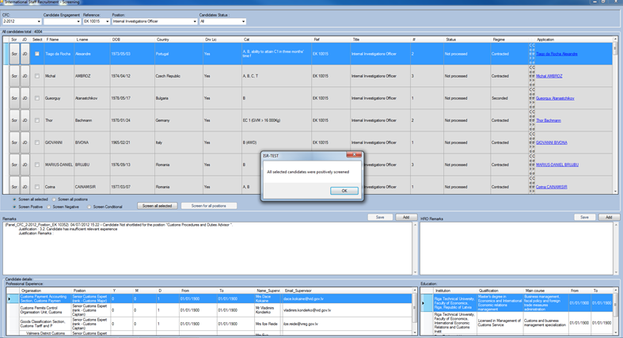

Andrei: Fixed ,see below.

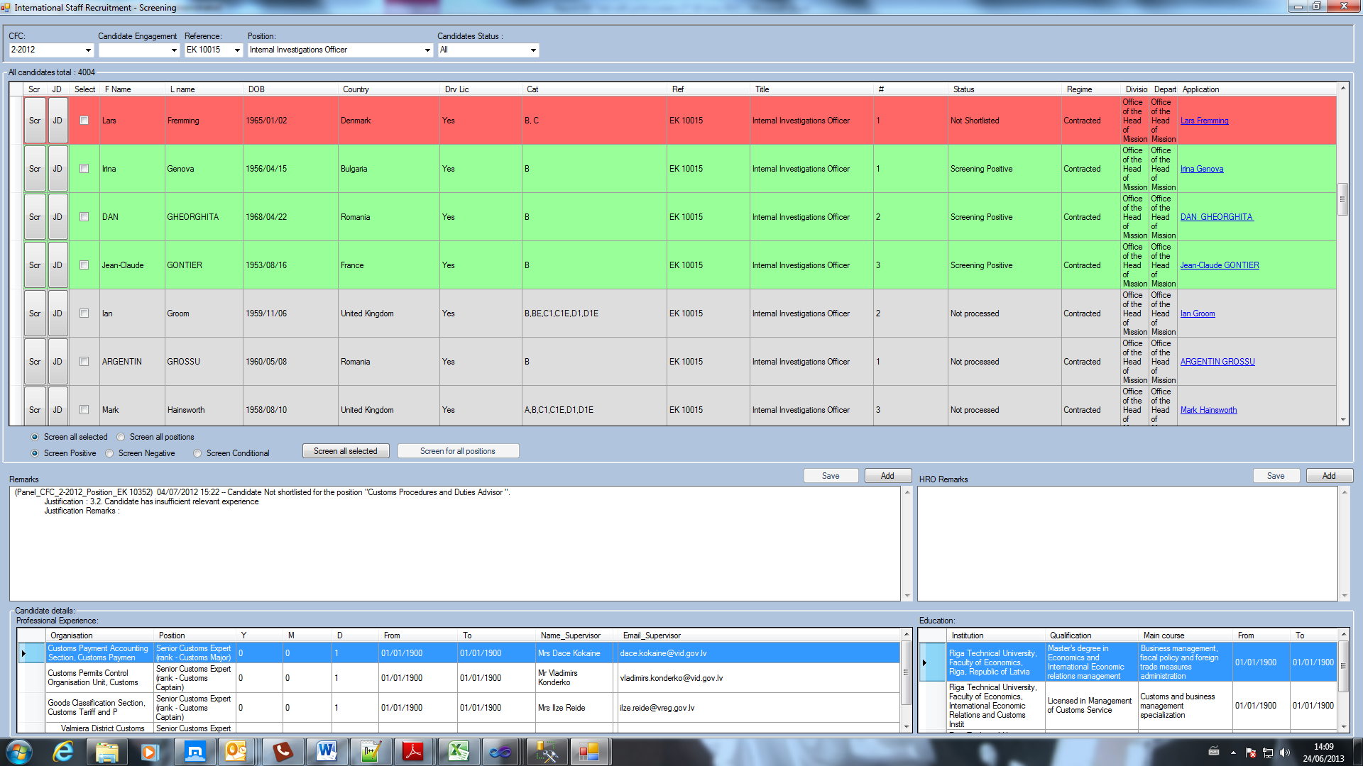

-When trying to individually screen each candidate, this is the error message popping up. However as you can see in the print screen, the candidates status changes to “screened positively” but the screening window still remains open and available for screening the candidate again.

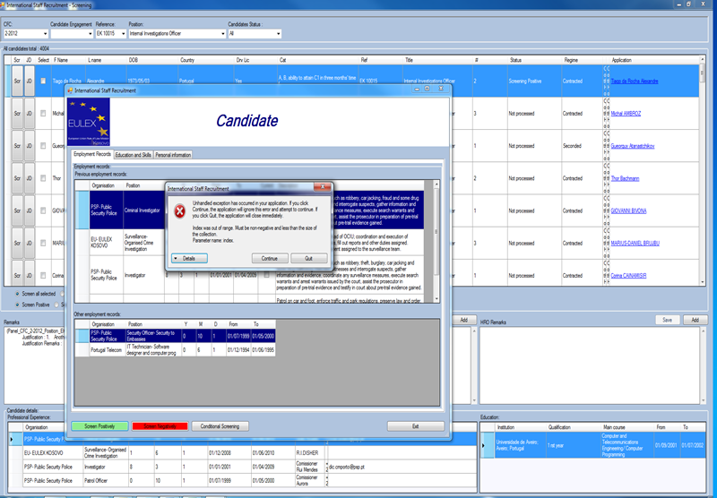

Andrei: Fixed ( see remarks below for Neil Fletcher-Positively Screened, then Conditionally Screened):

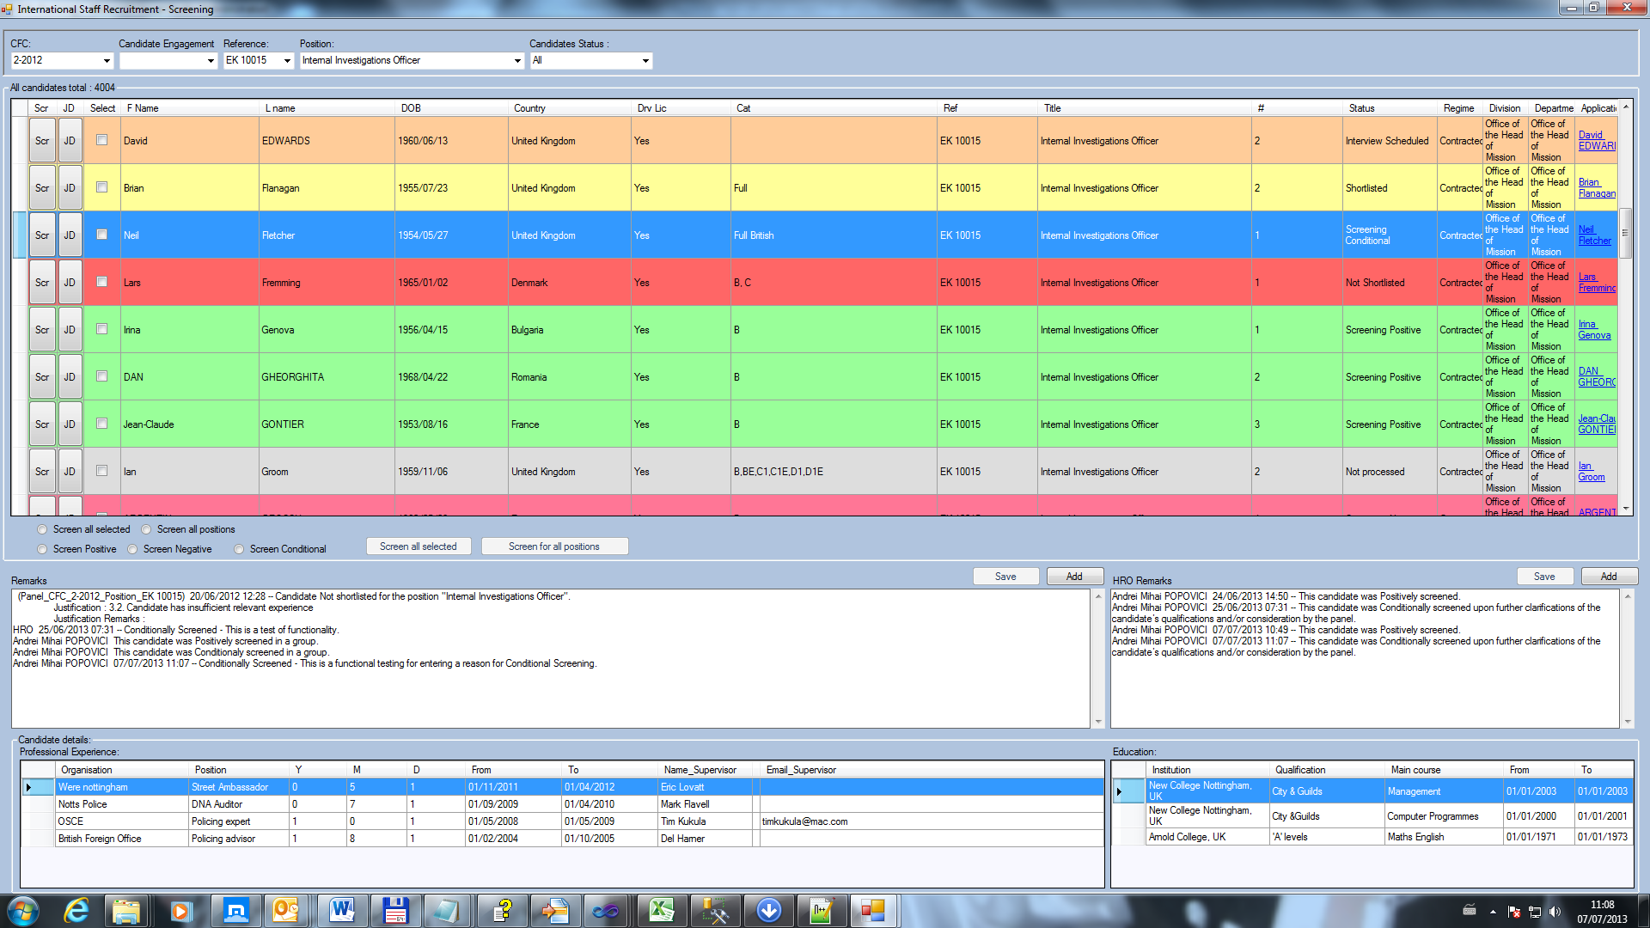

-Justifications for Screening: first 9 lines should be kept, and “Other”. All other justifications in between should be removed from the screening stage. Andrei: Fixed. See below.

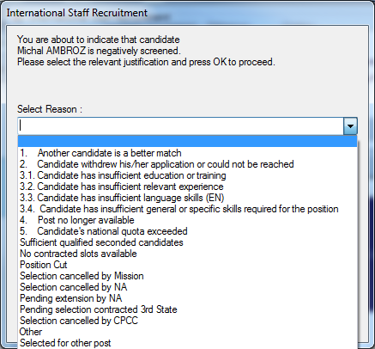

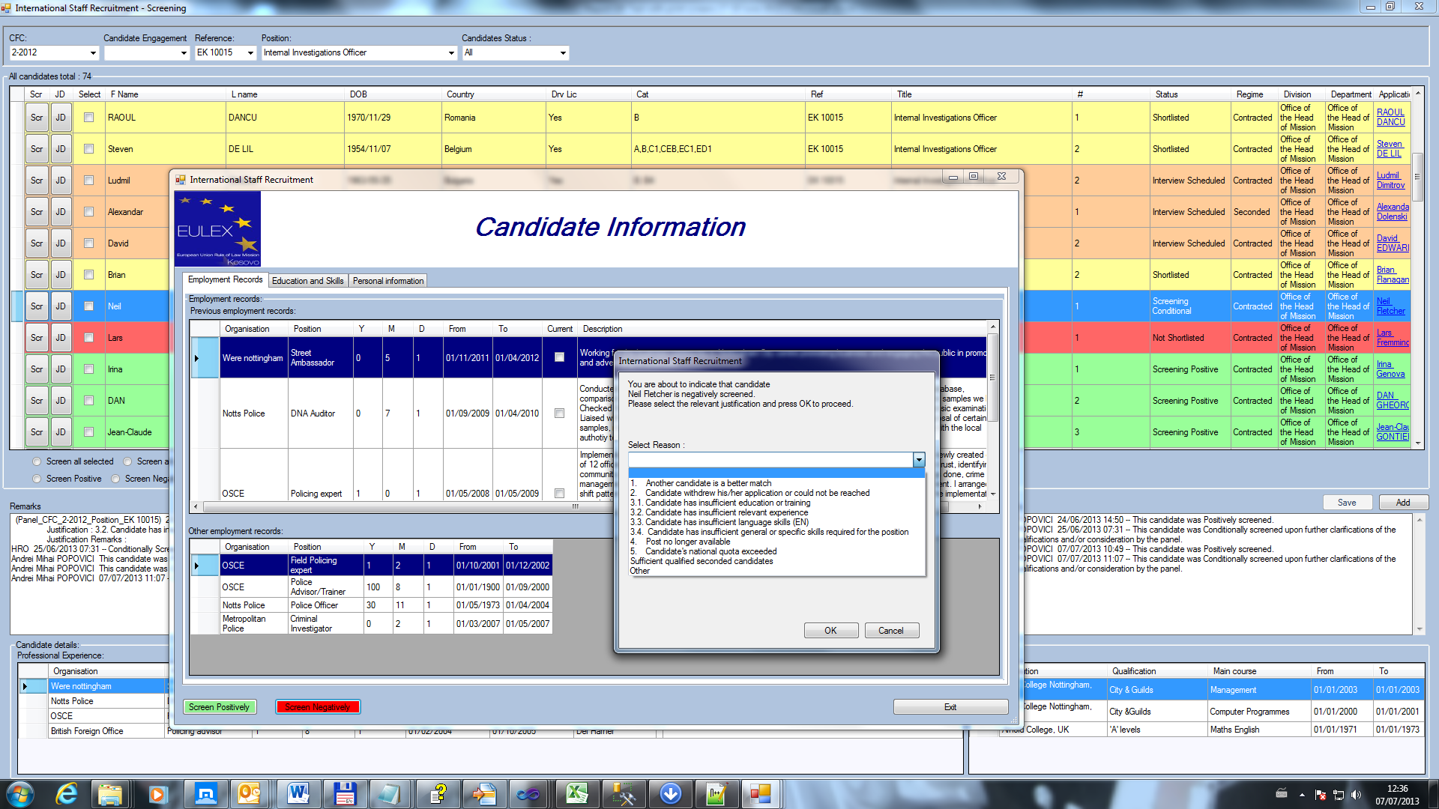

-Candidate was conditionally screened, but the remarks are not showing that, neither in HRO remarks or Remarks. Andrei: Fixed, see below.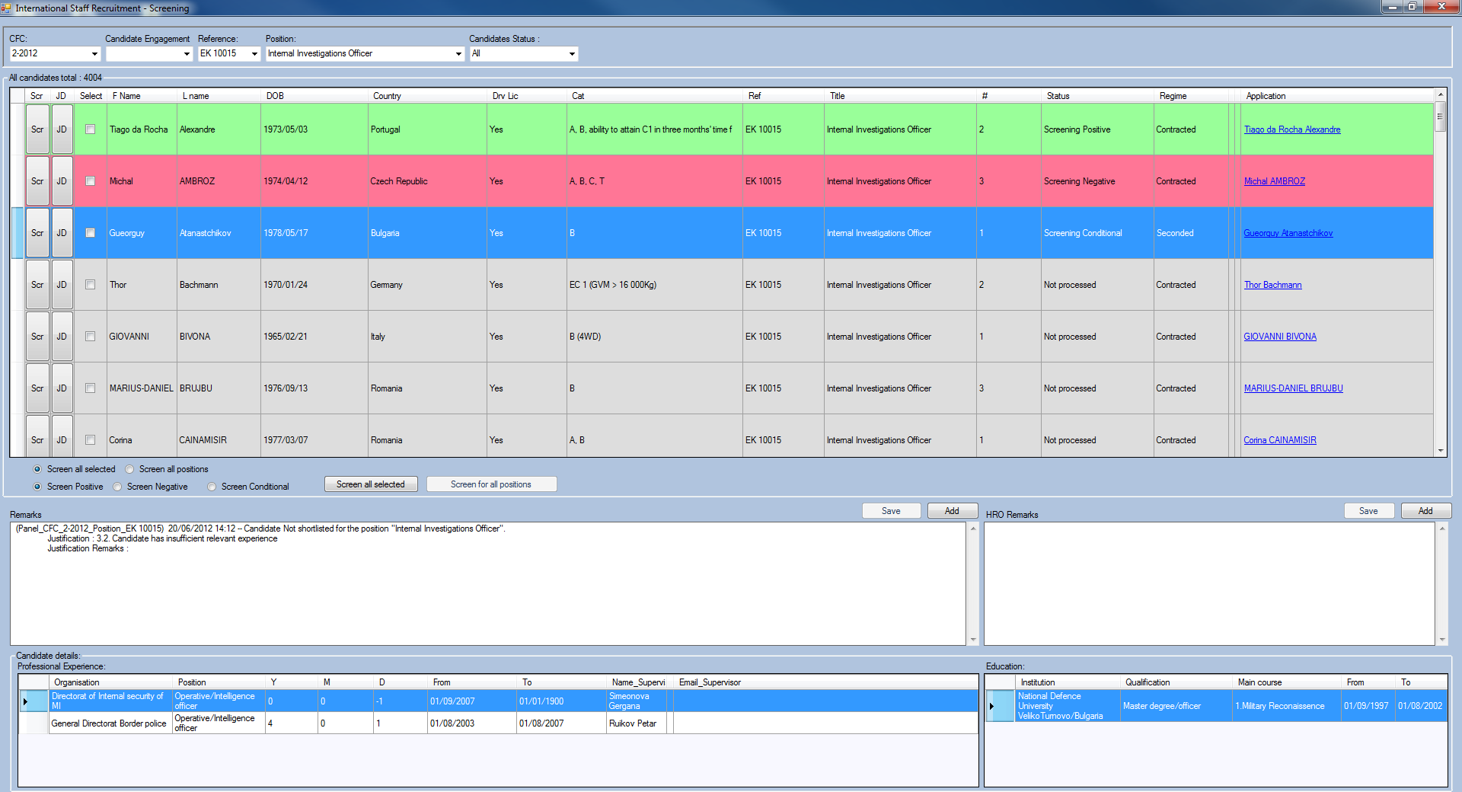

-When selecting one candidate after the other, the remarks do not change. The remarks remain from the previously selected candidate. Andrei:Fixed.

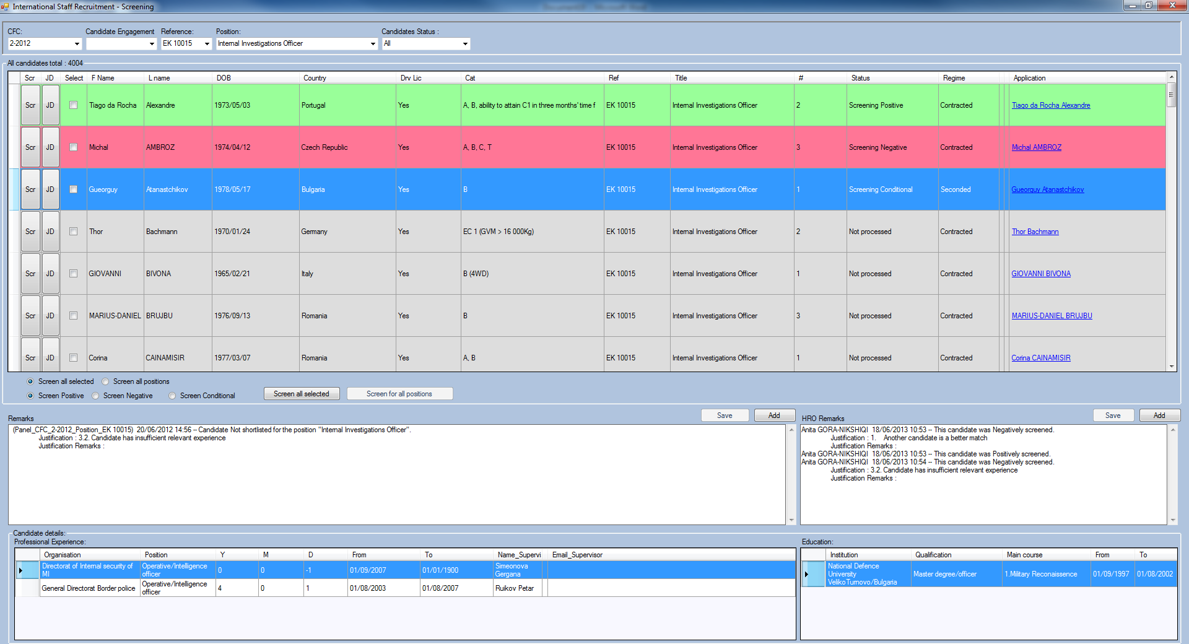

-When a candidate is being screened conditionally for all positions there is no pop up to request a reason as for individual priorities. Also it doesn’t show any remarks if the person was screened at all. Same when multiple selected candidates screened. Andrei:.

1. Implemented, see below.

2.Saving specific remarks when group screening( candidates/positions) has been implemented, see below.

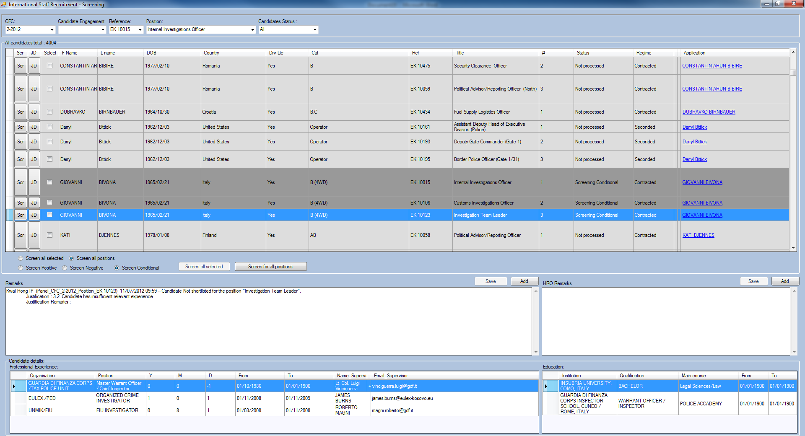

-Also when multiple candidates are screened negatively there is no pop up to enter justification. And no remarks at all

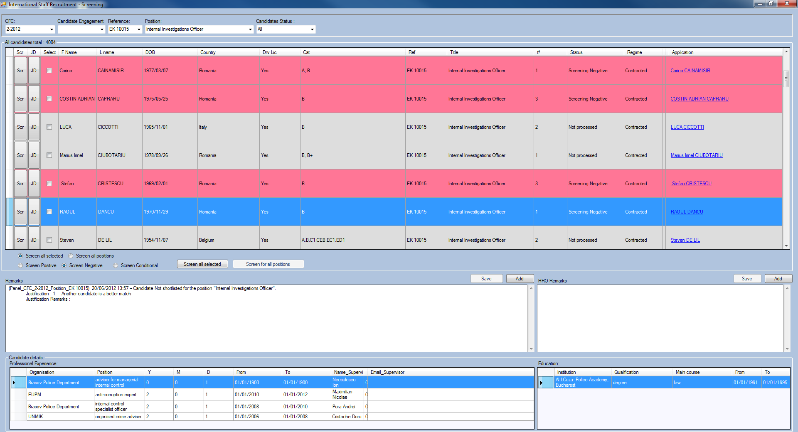

When screening a candidate for multiple positions, it screens even if a candidate has already passed the stage of screening for at least one priority (see 2 print screens below). This should not be possible. If a candidate is already processed further for at least one priority, when trying to screen him for all positions there should be a pop up message saying that *the candidate has already been processed for one or more of his priorities and screening can only be done for individual priorities not for al positions.*

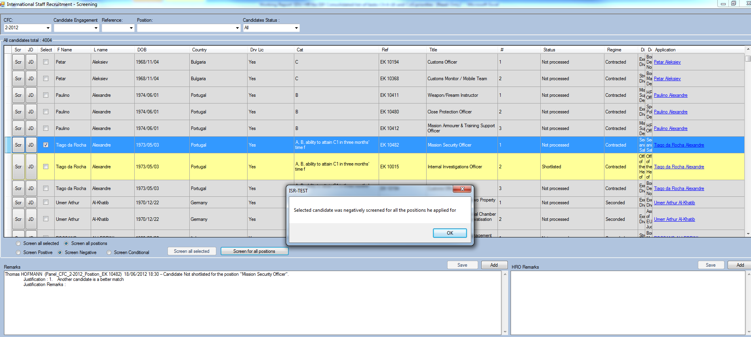

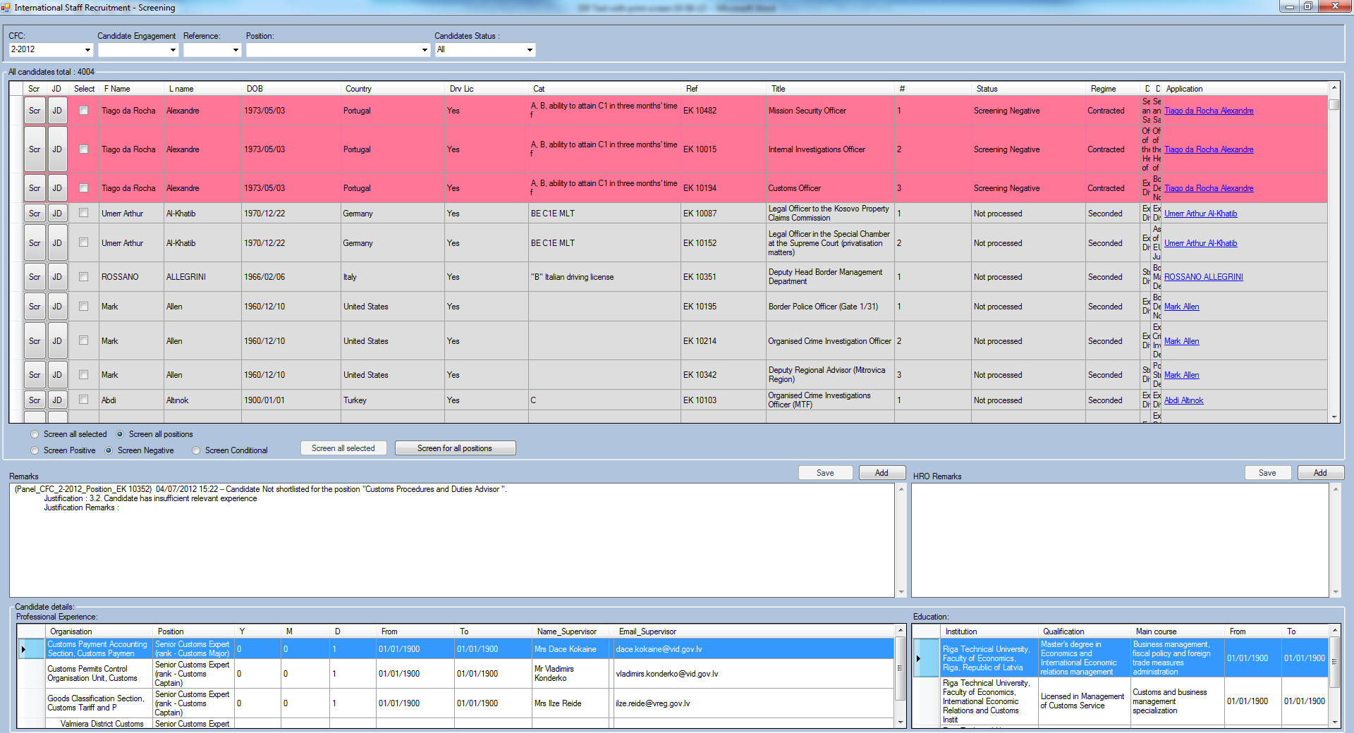

-Screening positive for multiple candidates does not work. Andrei: Fixed.

-Remarks are sometimes not being saved even when added directly in the remarks box. If/when saved they are not removed when a candidate is screened positively afterwards. Andrei: Fixed, related to previous bugs.

-Colors for different screening status suddenly disappeared

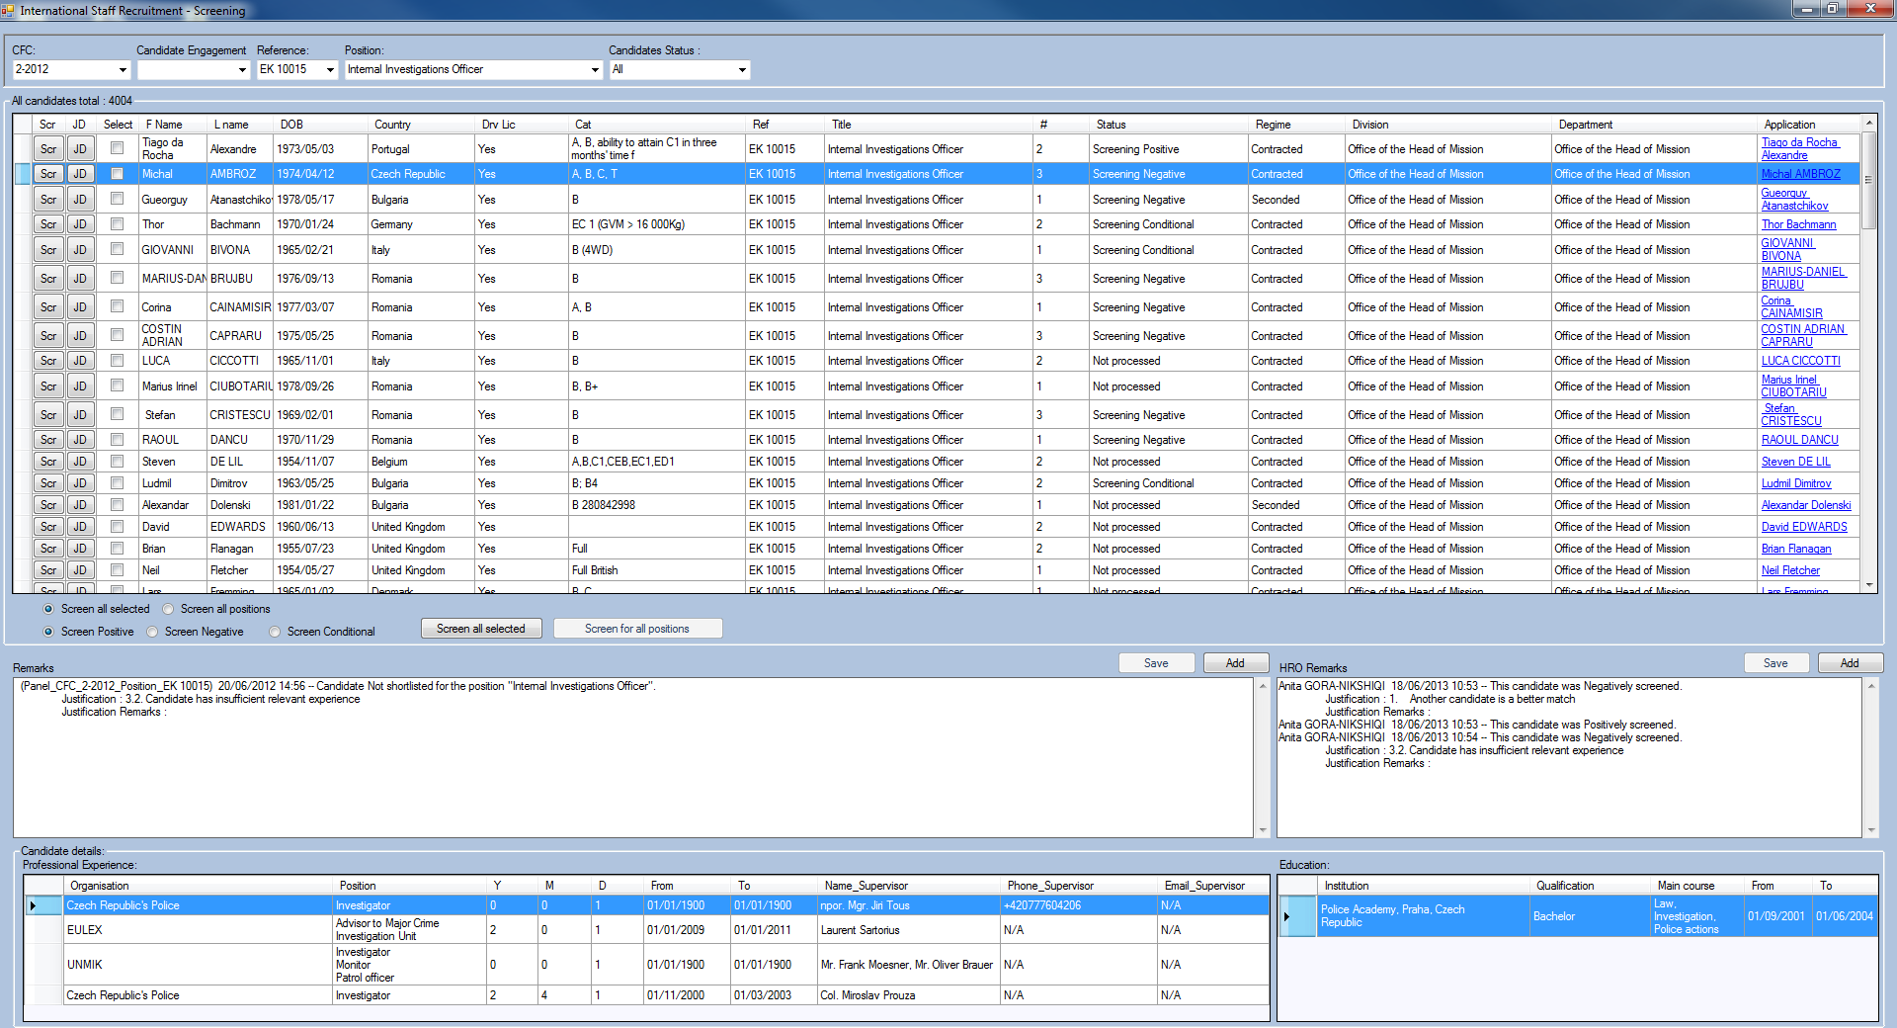

-If a candidate is positively screened once and then conditionally or negatively, the remarks disappear from HRO remarks. But none show in the Remarks.

-When only one candidate remain in the window or filtered, the data of another candidate is visible (employment and education) even when clicking on the candidate doesn’t change the data to show the correct candidate.

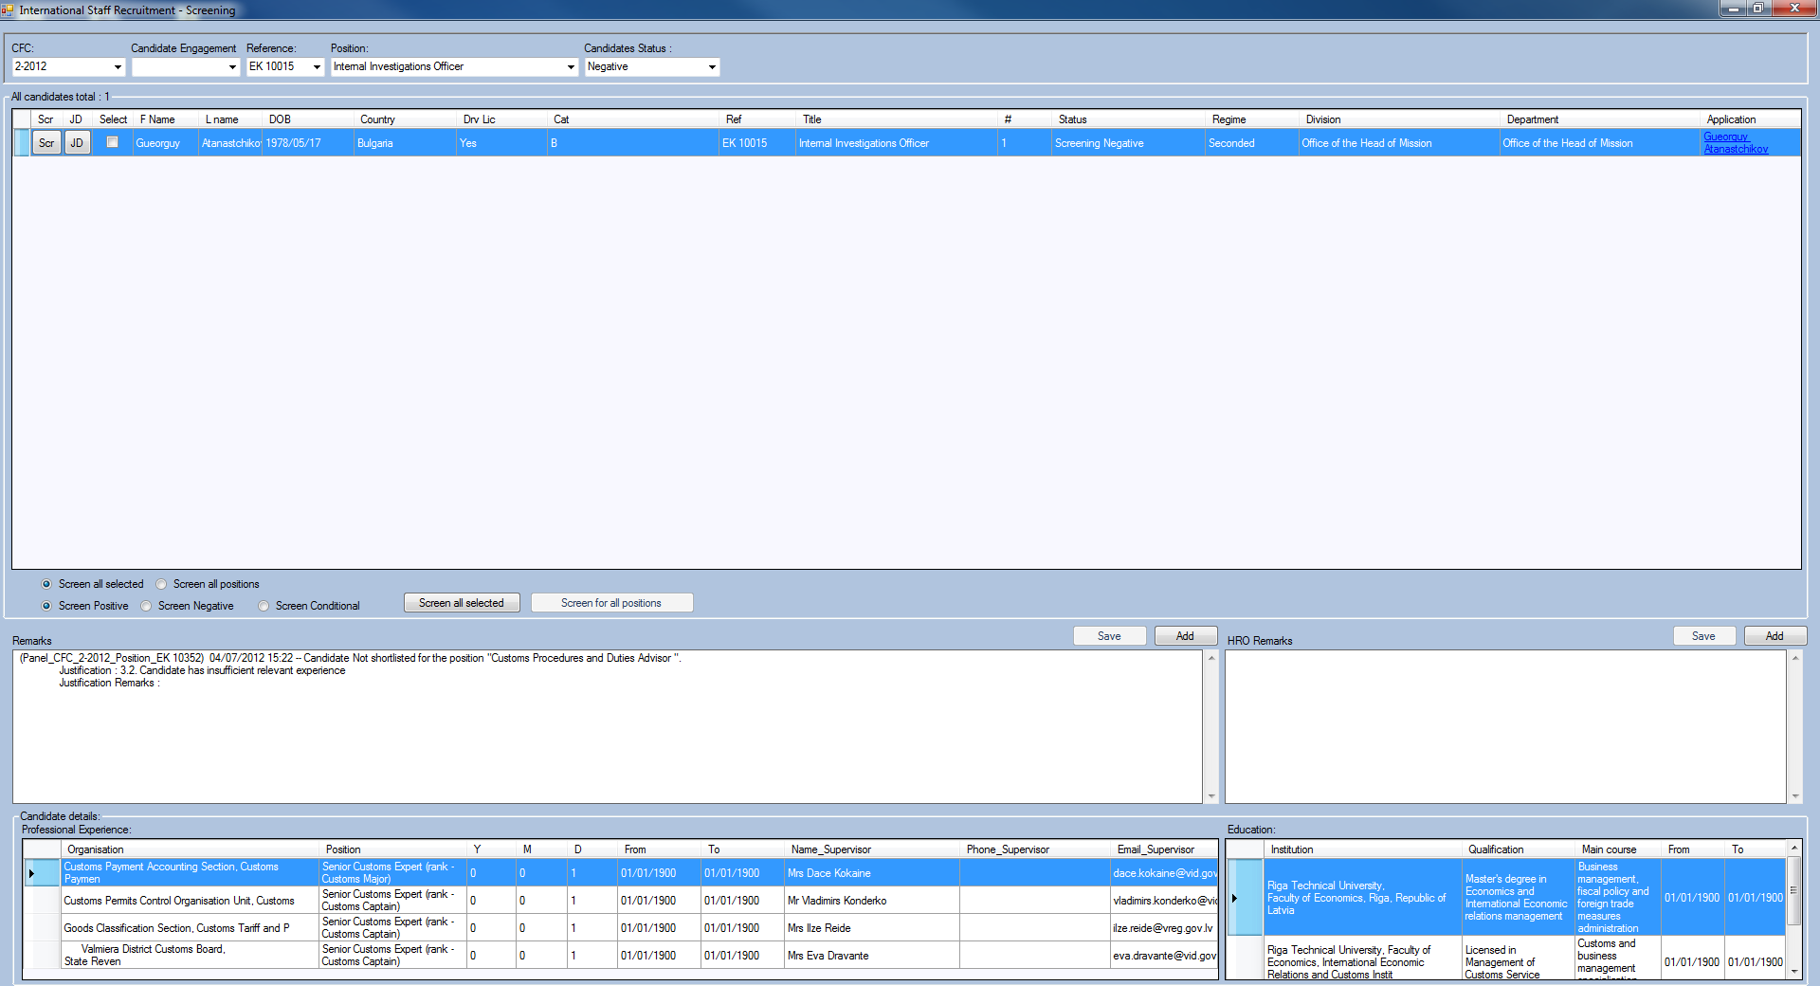

-The buttons for shortlisting and schedule interview are not being expanded automatically all the time.

* A warning pops up while trying to shortlist a candidate. It pops up I guess when there is no Ref. no selected, but besides the possibility to select a ref. no. for HRO there should also be a column of position and ref. no. added to be able to see what are the candidates shortlisted for. And if a candidate cannot be shortlisted without selecting a ref. No. the pop up message should say exactly that.

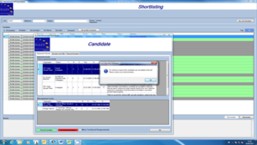

-No remarks are shown for the conditionally screened candidates. Panel should be able to see the reasons why the candidates were screened conditionally and any other remarks added for their attention.

-When filtered by regime, only the not marked and shortlisted candidates are visible. The not-shortlisted candidates are not visible.

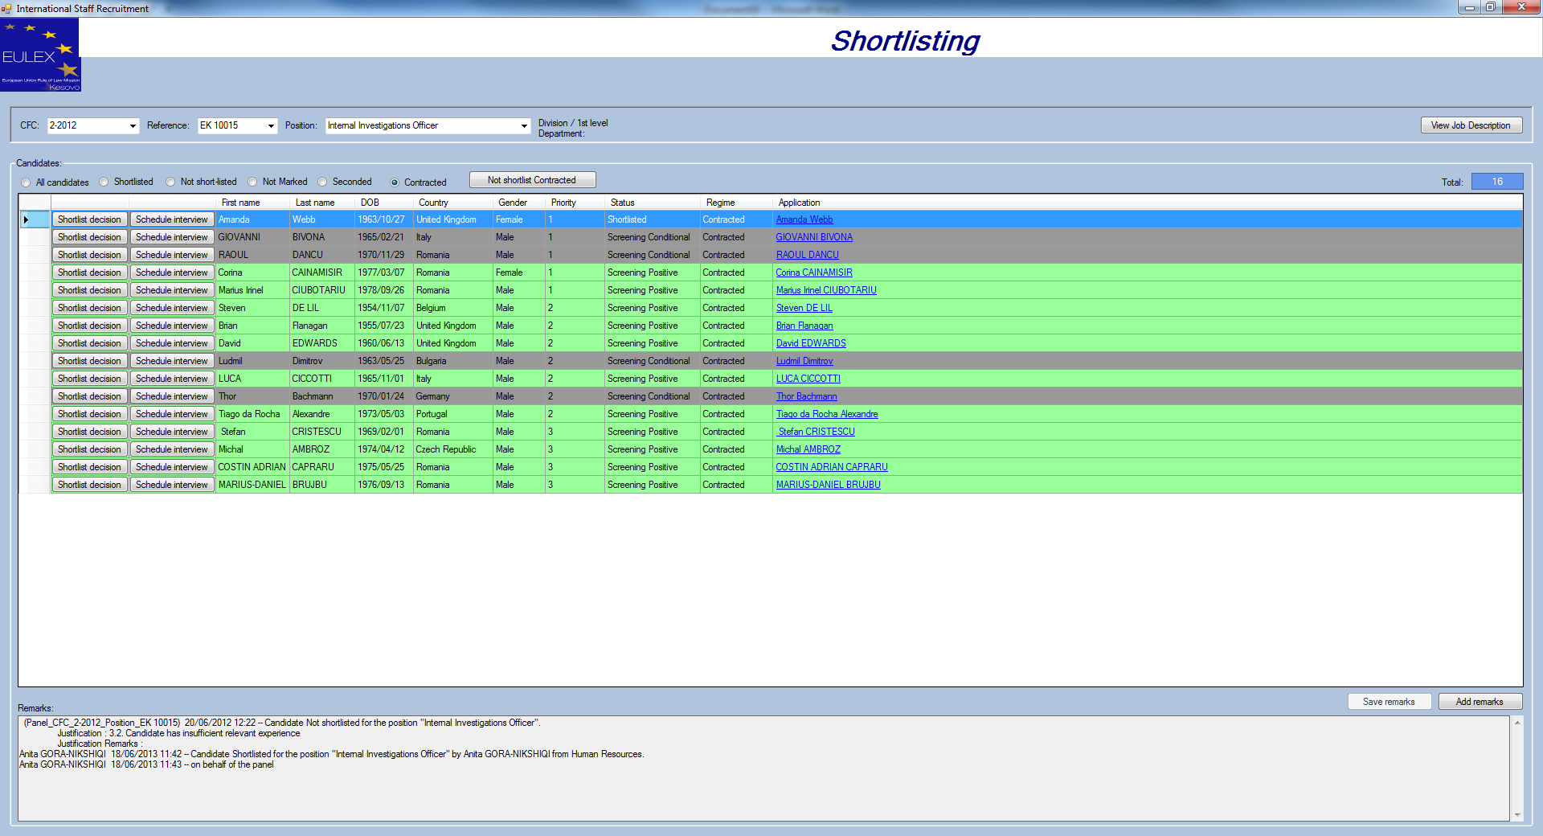

-It is possible to not-shortlist a seconded candidate with a justification code “1” while a contracted candidate was shortlisted (this should not be possible).

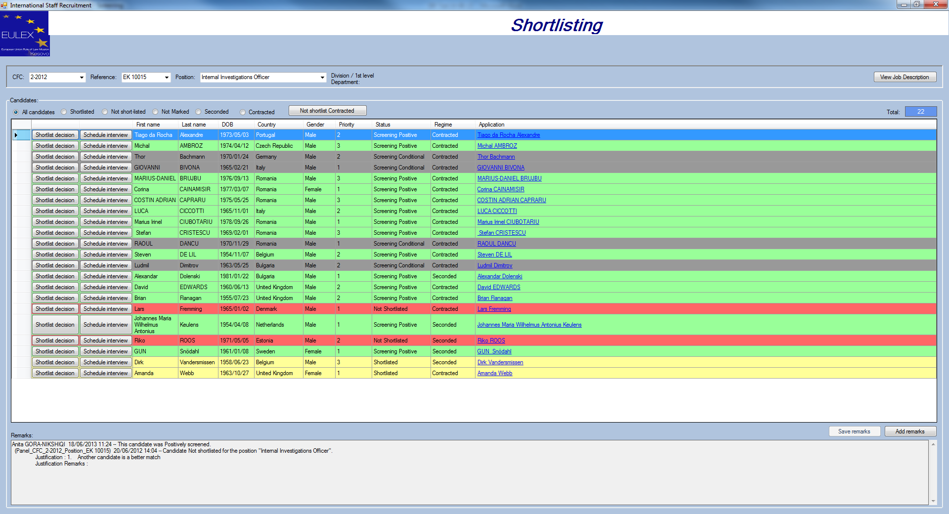

Not shortlisting all contracted candidates is not possible when at least one of the contracted is shortlisted. The pop up message says they are not shortlisted. The pop up message should say that there are contracted candidates shortlisted and it is not possible to “not shortlist” only a number of them.

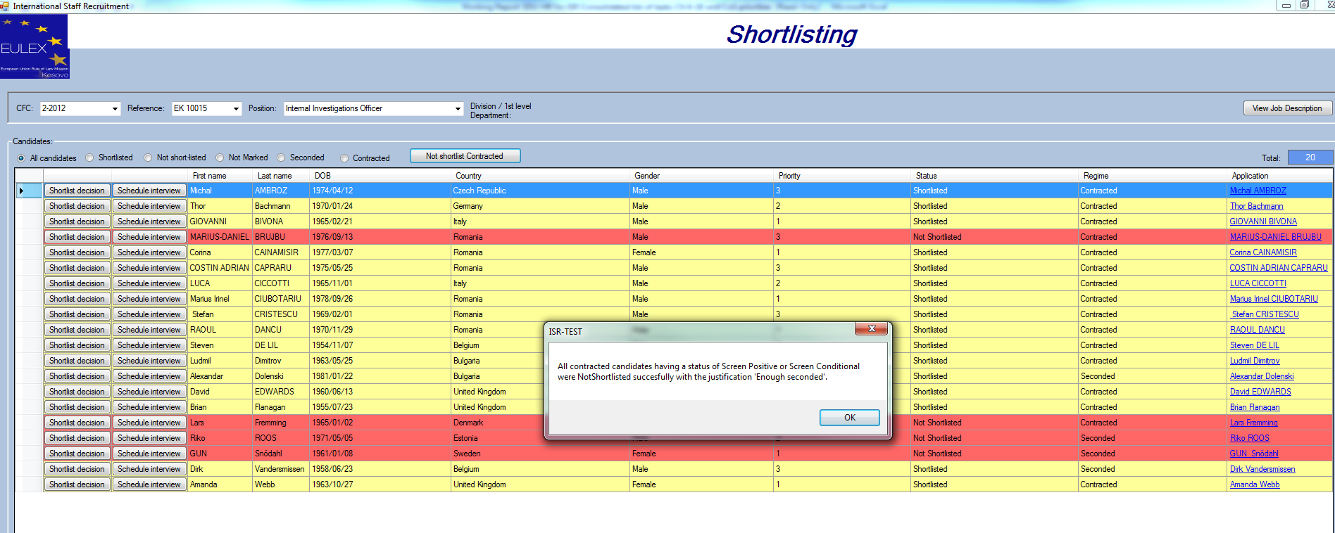

**Scheduling interviews did not work. It was fixed on 20th June. Here is the report:**

-Panel members’ name and last name not shown.

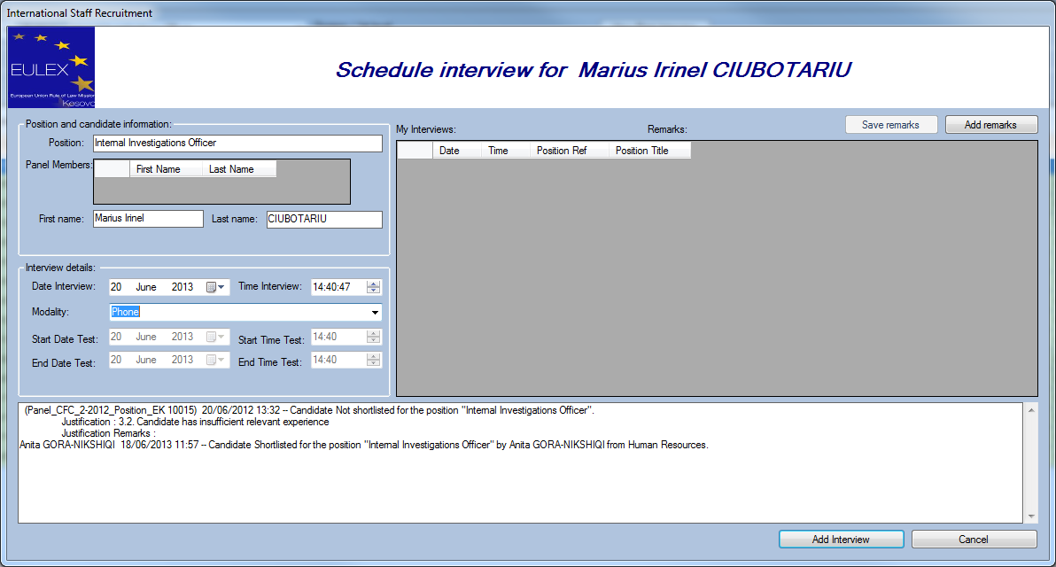

Andrei, 24/06/2013: Fixed.

-Time format is **hh:mm:ss and the panel has to type the seconds in as well plus there is no dropdown menu as requested. This should not be the case. “Time Interview” by default it should be 30 minutes interval between all the short-listed candidates. Time intervals of 5 minutes (and not of 1 minute) shall be shown in the drop-down menu of “Time Interview”.**

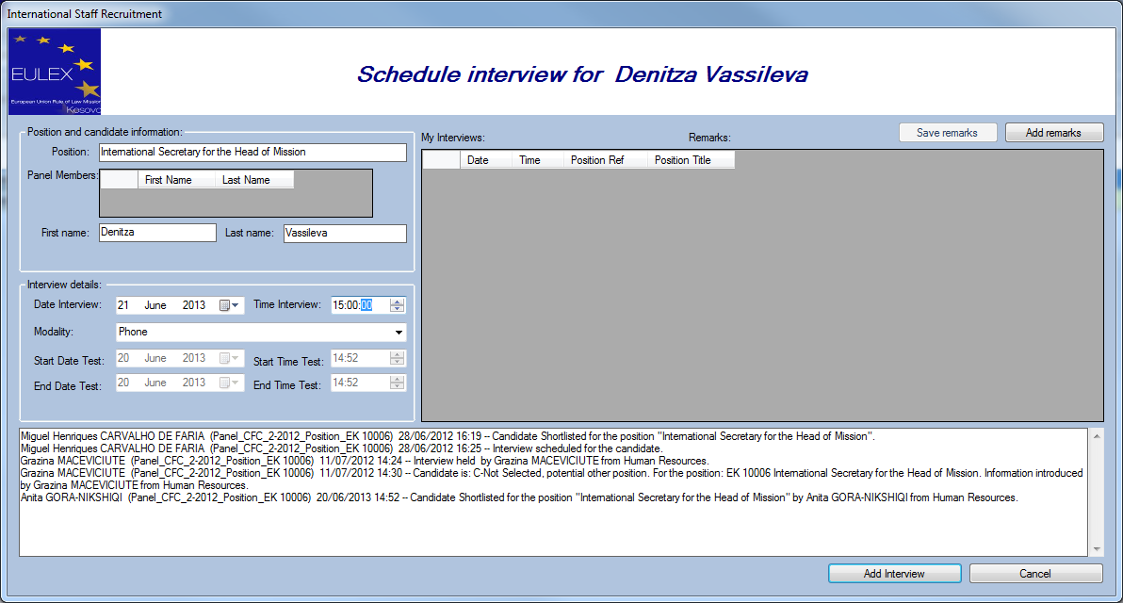

-Date of interview should by default remain the same for all other candidates as for the first candidate. It is not working.

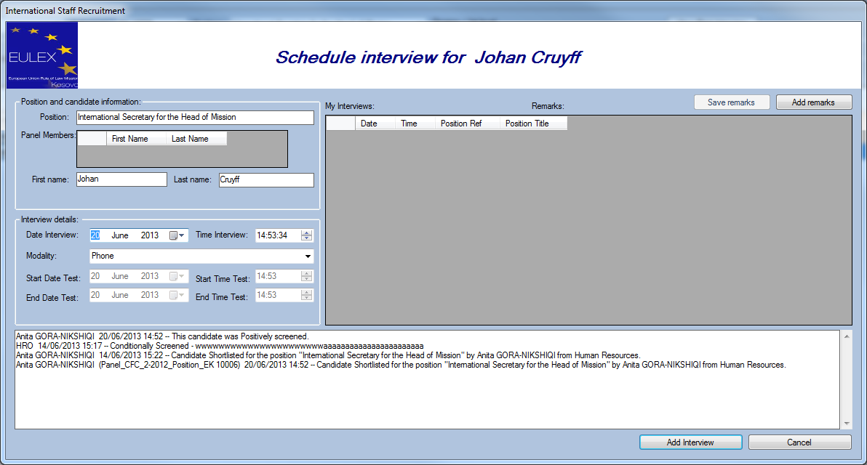

-The candidate is duplicated with different interview dates.

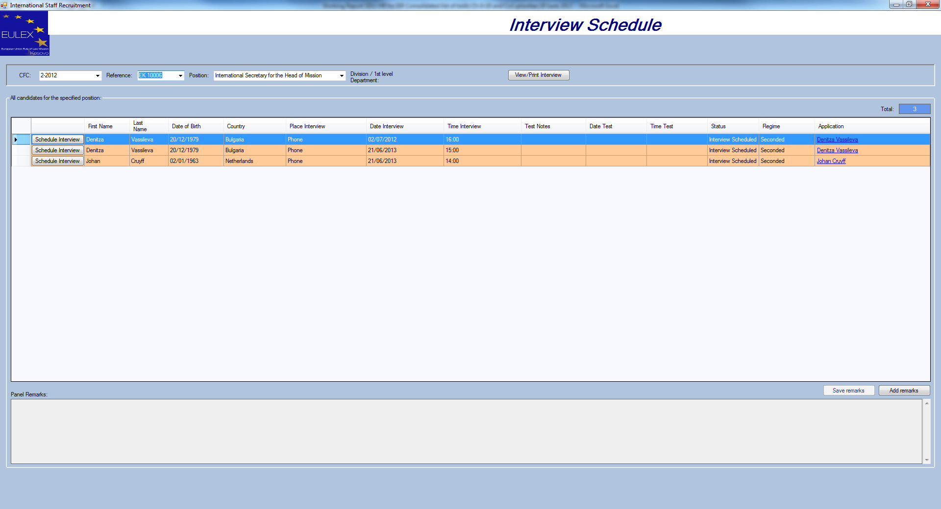

-Remarks are visible at the bottom but the remarks (title) and buttons for adding and saving remarks are on the top right hand side.

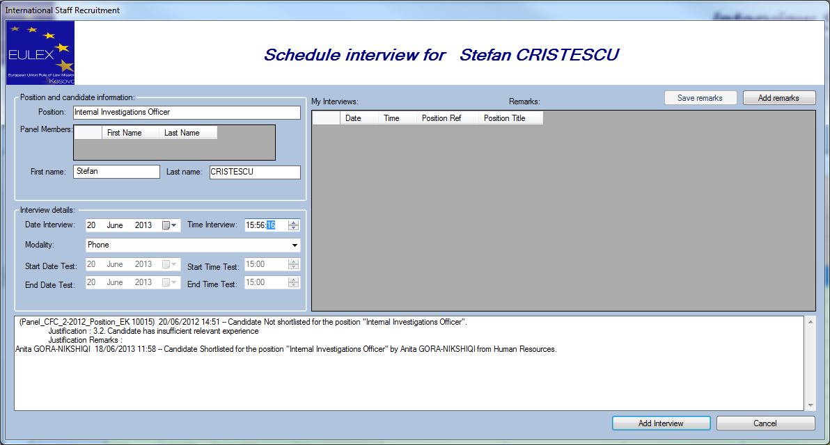

-The field under End date test, should be called Test Notes.

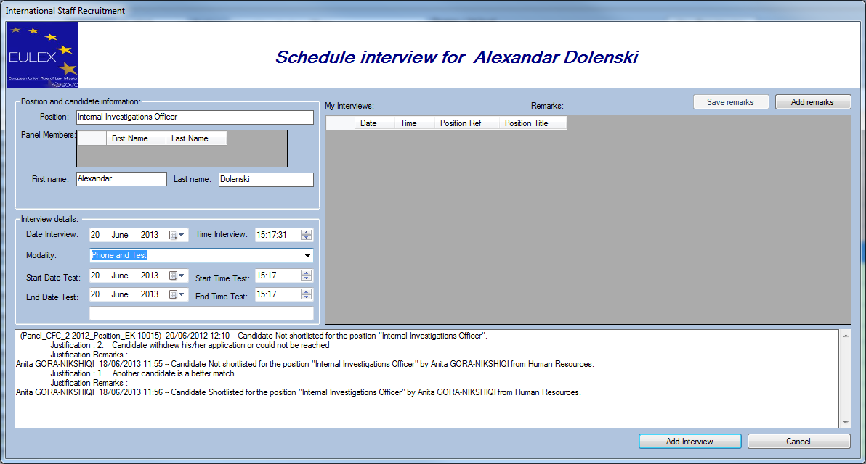

-Trying to open “Interview results” window, an error pops up.

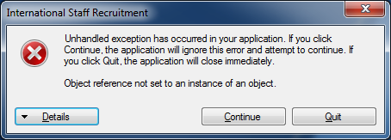

-When clicking “continue” this is what opens. No CFC, no candidates.

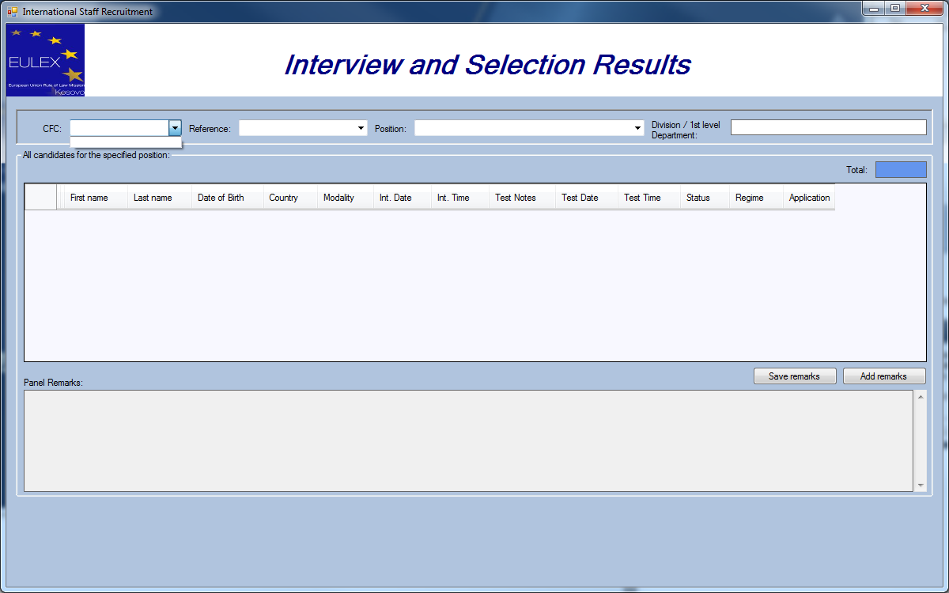

No further test can be done as next stages are not working.